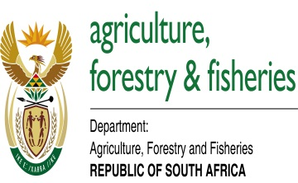

National Arbor Week Celebration
The Department of Agriculture, Forestry and Fisheries in partnership with the Eastern Cape Department of Rural Development and Agrarian Reform hosted National Arbor week from 1 September, 2017 at North End sports ground in the Matatiele Local Municipality in the Alfred Nzo District, Eastern Cape Province. The event was attended by more than 800 participants from different institutions and surrounding communities around the Matatiele area. In attendance were the Minister and officials from the Department of Agriculture, Forestry and Fisheries, the MEC and officials from the Eastern Cape Department of Rural Development and Agrarian Reform, members of the Traditional Leadership (Amakhosi) Chairperson of the Forest Sector Charter Council, Vice-Chairperson of the National Forests Advisory Council, the Mayor of Matatiele Local Municipality, the Executive Mayor of the Alfred Nzo District Municipality, councilors. The Minister of Agriculture, Forestry and Fisheries, Mr Senzeni Zokwana said that South Africans have come a long way in celebrating the National Arbor Week, which is one of the important campaigns in the agriculture and environmental calendars. Arbor Day was first celebrated in our country in 1983. This captured the imagination of people who recognised the need for raising awareness of the value of trees and forests in our society. As sources of primary societal needs such as building material, food, medicine and simple scenic beauty, trees and forests play a vital role in the health and well-being of our communities. Collective enthusiasm for the importance of these issues in South Africa inspired the National Government to extend the celebration of Arbor Day to National Arbor Week in 1999. From 1 to 7 September every year, government institutions, schools, communities, businesses and organisations are reminded and encouraged to participate in community "greening" to improve the health and beauty of the local environment. In recent times, the scope of the Arbor Week campaign and the greening function has grown to include issues of global importance such as conservation of species biodiversity, food security and mitigation of green-house gasses that lead to global climate change.

The year 2017 has been declared the year of Oliver Reginald Tambo. It is the year of unity in action by all South Africans as we together move South Africa forward. We hope it will be the same in greening that we can get the government, private sector, community-based organisations and non-government organisations working together towards the greening of our country. Though the situation has improved in other areas, sectors such as agriculture and forestry are still feeling the effects of drought on production and general issues related to climate. These prevailing drought conditions could be a sign that the effects of climate change, which manifests itself as global warming, are already starting to set in. This means climate change is now a reality. For this reason, the Department has decided to retain the theme “Forests and Water” so that, as we promote tree planting to mitigate against climate change and to address household food security, we are mindful of the fact that we should concentrate on indigenous species that helps to conserve water. It is again for the same reason that the Department promotes the trees of the year. For this year, the Buffalo thorn and Ebony trees have been selected as Trees of the Year. The Trees of the Year are selected from the species that are becoming extinct from our indigenous heritage. One species is common and the other is rare in terms of occurrence. The Million Trees Programme is an innovative public greening initiative that was launched in 2017 with the main aim of contributing nationally towards the improvement of quality of life and contributes to the development of sustainable human settlements. The programme provides low-income communities with fruit trees to plant at their homes. It also targets schools, early learning centres, clinics and old age homes. The aim is to plant at least a million trees across the country annually.

As part of the implementation of the greening programme, it is estimated that about 3 000 trees would have been planted by the end of the campaign throughout the Matatiele Local Municipality. The Department has developed a national greening strategy which aims to support local government, non-government organisations, community-based organisations and other role players such as the corporate sector to initiate and implement greening interventions. The greening strategy’s main focus is to assist municipalities to develop greening plans at local level and to ensure that greening is included in the Integrated Development Plans (IDPs). According to the results of the 2015 revision, the world population reached 7,3 billion as of mid-2015, implying that the world has added approximately one billion people in the last twelve years. According to this report, it is predicted that the world population will continue to grow and more than half of the global population growth between now and 2050 is expected to occur in Africa. This has serious implications for food security. Traditional methods of food production and nutrition need to adapt to the changes and growing demands for food. This means that primary production of food is faced by a myriad of challenges amongst them competing for natural resources for production, with land being the primary and crucial one. As food prices increase because of the global economic instability, many South Africans cannot afford to buy healthy food because the basic staples become scarce and expensive. Therefore, the Department has joined the nation in embarking on the greening the nation initiative. A healthy, diverse and productive environment treasured by the whole community. Through greening and Climate Smart Agriculture, food insecure households will have access to environmentally-friendly agricultural technologies, resources and training and capacity to reduce hunger.

Forestry through jobs in rural areas creates an environment where households derive an income to buy food and other items in the household. However, where small growers are involved, small plantations could be integrated with food gardens or cash crops to ensure household food security while awaiting the trees to grow. Such an agroforestry system could be one of the key pillars for reducing hunger and poverty in both urban and rural areas. As a result the Department has finalised the development of the agroforestry strategy and implementation plan. The strategy will be piloted for implementation in phases in Limpopo, Mpumalanga, the Eastern Cape and KwaZulu-Natal.

He lastly said that the Arbor Week Campaign and the Arbor City Awards competition would not be a success without our partners and sponsors. Total South Africa has been sponsoring the three programmes, namely; Arbor Week, Million Trees Programme and the Arbor City Awards. Our appreciation goes out to them, without their support the impact of our greening programme would not have taken place in such a short period. In addition to Total South Africa, the Department would like to thank other partners and role players who, through their efforts, we are able to make our country green and a better place for all people to live in. The general community and other sectors such as business and non-government organisations are invited to join hands with Government so that we can achieve our goal of greening the country. Government cannot do it alone and we need your support. Working together we can achieve greening of our country.

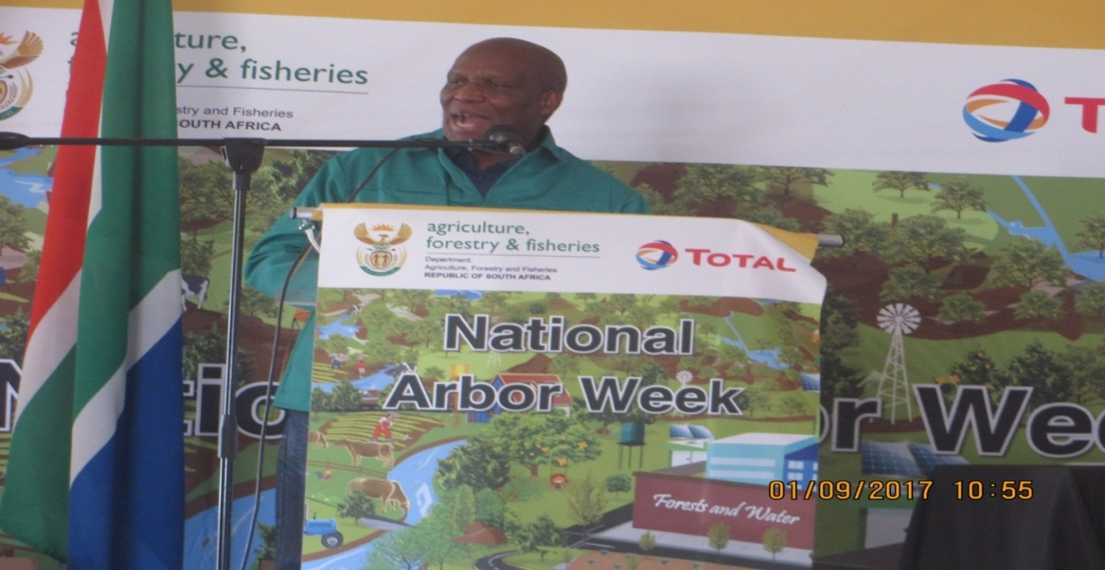
Minister of Agriculture, Forestry and Fisheries, Mr Senzeni Zokwana addresses the participants during the National Arbor Week.

